# Theoretical Background

Spectral Analysis

Spectral Analysis of errors for a numerical scheme is a well established method for understanding the behaviour of the given numerical scheme. It can also be used for studying the behaviour of a numerical scheme on different types of meshes (quadrilateral and triangular). A detailed theory of spectral analysis of numerical errors for hyperbolic problems is developed in [4].

A 2D wave equation is (2.1) For any planar wave, the *dispersion relation* associates a *pulsation function* to the wave number. For wave equation (2.1), it could be written as (2.2) where is wave velocity given by and is where and are *wave numbers in x and y direction* respectively. For a given numerical scheme, the amplification factor **G = G(wave number, scheme parameters)**.

In spectral analysis, for a given numerical scheme on a given mesh topology, *Amplification Factor (G)* can be written in polar form as

(2.3)

Then, for hyperbolic problems, the *diffusion or dissipation* error is defined as

(2.3)

And *Dispersion* error is defined as

(2.5)

Here and

For any scheme, should be as close to 1 as possible (but never greater than 1). should be 1 for a dispersion free scheme.

Jameson, Schmidt and Turkel (JST) Scheme

The JST [1] scheme is one of the most popular numerical scheme for solving Navier Stokes equations in the industry. It is a central scheme with artificial dissipation to stabilize the inherent unstable nature of central difference schemes. It owes its popularity to its ease of implementation and reasonable accurate results for a wide range of Reynolds number and Mach number flows. Jameson’s original paper was for structured grids and in 1985 Jameson and Mavriplis came up with triangular mesh implementation [2]. There have been many variants of this since then but triangular mesh implementation of JST scheme has largely remained relatively less concrete in literature with codes defining their own constants and scaling that suited their range of implementations [3].

# Spectral Analysis for JST scheme of 2D Cartesian Mesh (Structured)

JST scheme is used to discretize NS equations on a uniform Cartesian mesh and their errors are analysed for dispersion and dissipation. The model equation is the 2D wave equation –

(4.1)

The finite volume discretization would give

(4.2)

The central difference terms and and the artificial dissipation terms and are discretized as in [1].

This gives

 (4.3)

The artificial dissipation terms are discretized as

 (4.4)

Again and are as defined in [1].

Using model solution for the equation (4.1) as gives

 (4.5)

 (4.6)

Here and and are wave numbers in x and y directions respectively. is square root of -1.

On replacing (4.5) and (4.6) in (4.2) one gets

 (4.7)

The equation (4.7) is in the form

(4.8)

Runge-Kutta step 3 explicit method as described in [1] is used to march in time. This method has an amplification factor

(4.9)

Comparing equations (4.8) and (4.7) gives

(4.10)

# Post-processing

From equation 4.10 and 4.9 it can be seen that amplification factor G is a function of ,,,and .

(5.1)

For simplicity it is assumed that , that is to say that Courant number along x and y direction is taken to be same. This means that it is assumed that wave velocities along x and y directions (*a* and *b* in equation 4.1) are same.

The dissipation constant is a parameter that can acquire any value between 0 and 0.25. This can be seen by looking at the definition of in [1]. and , which represent the wave angles along x and y directions are treated as independent parameters refining a R2 space. Four error forms are defined –

1. Max. Diffusion error ( : For stability, this value should be less than 1 for all values of and .
2. Min. Diffusion error ( ) : This is the maximum dissipation the scheme offers for a given set of parameters (ε2 and σ) for the entire range of wave angle. Smaller this value more diffusive the scheme could be.
3. Average Diffusion error ( ) : This is the average diffusion error for the complete range of wave angle for a given set of parameters.
4. Dispersion error ( ) : This error quantifies the dispersion error for the scheme for given ε2 and σ. A value of 0 means there is no dispersion and numerical and actual speed of propagation of waves are same.

The above mentioned errors are plotted (contour plots) on a plane described by ε2 and σ. ε2 is varied between 0 and 0.25 while σ is varied between 0 and 1.2.

# Contour plots

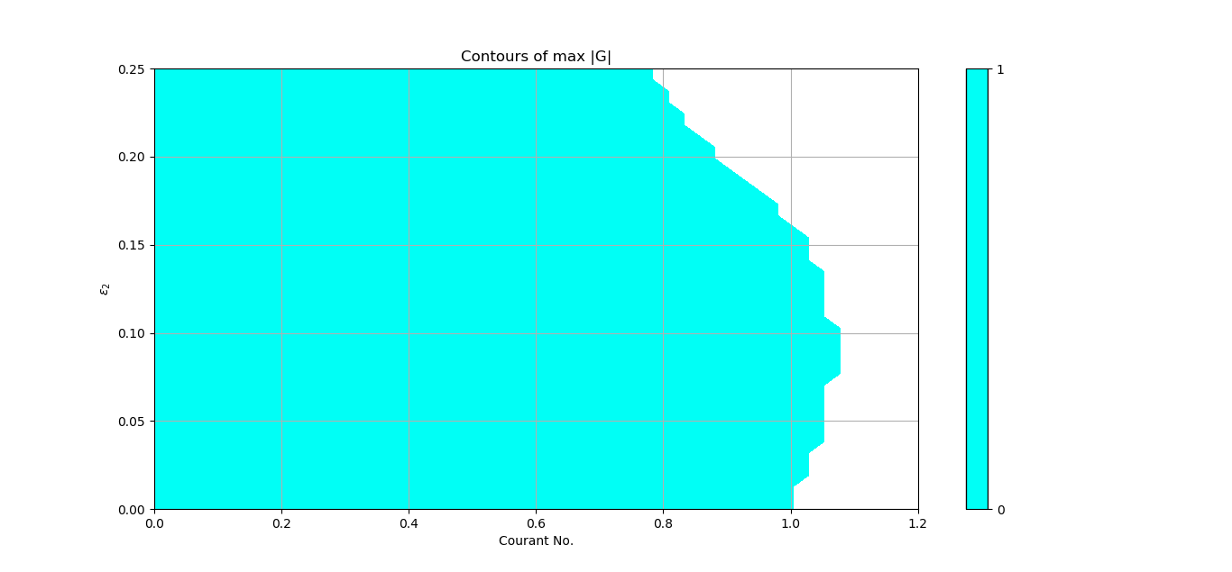

Figure : Stability region for JST scheme on rectangular meshes

The above graph shows the region where is less than 1 for all values of x and y wave numbers. This shows that the JST scheme for structured mesh is stable up to a very high Courant number (>0.8) for all possible values of ε2. In real simulations, ε2 is not an independent parameter but depends upon local flow condition (pressure gradient). It rarely goes as high as 0.25 except possibly near shocks. For most regions of flow, it is actually pretty small (very close to 0) and the 4th order coefficient is active.

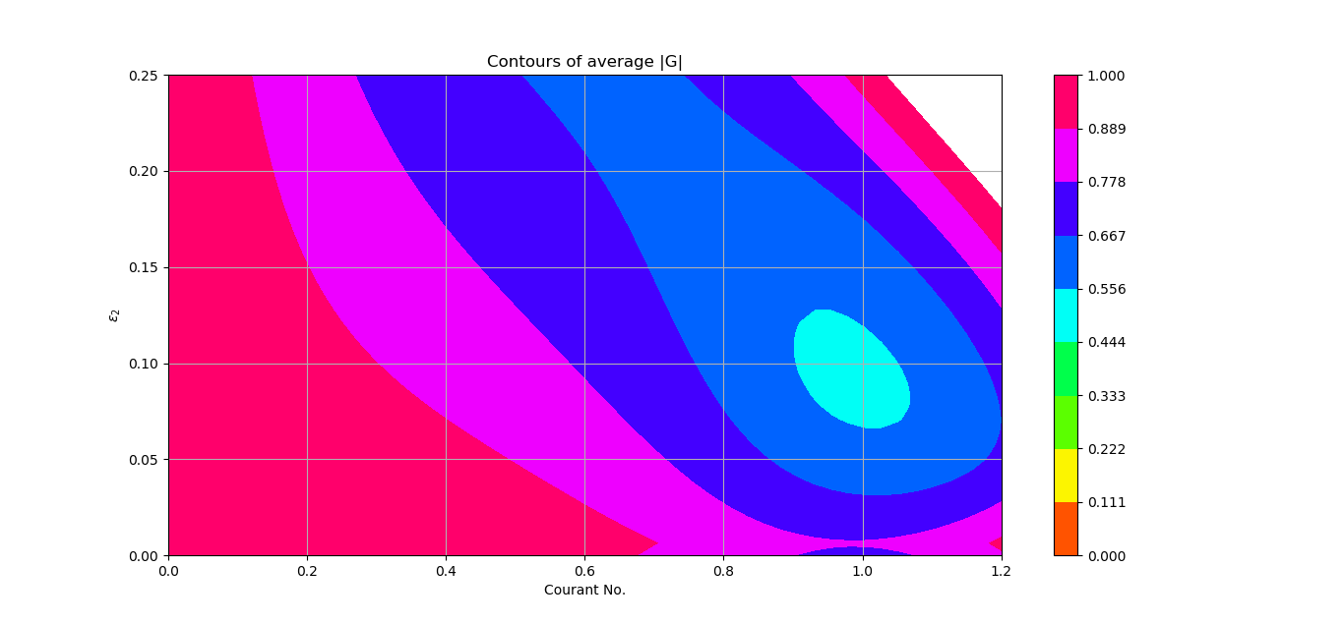

Figure : Average mod(G)

The bottom left region of the plot shows the region with minimum diffusion. In fact, it shows that for uniform Cartesian grids, lower the Courant number, lesser is the diffusion shown by the JST scheme.

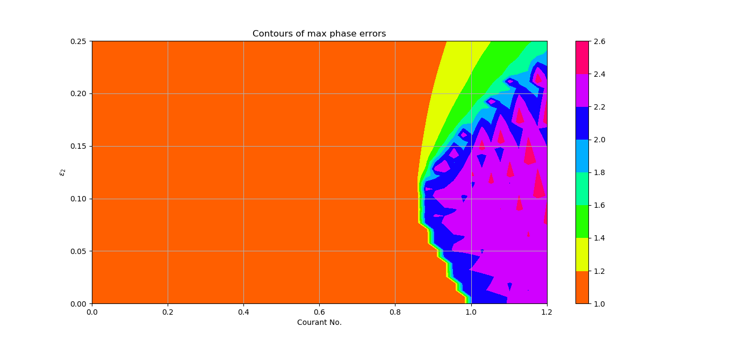

Figure : Dispersion error for structured JST scheme on uniform cartesian grid

The above plot of maximum dispersion error for structured JST scheme shows that the scheme shows a maximum relative dispersion error of 1 for some wave number or the other in entire region of stability in ε2 x σ plane. It is interesting that this property of JST scheme has not become point of contention in past nearly 40 years of existence of JST scheme. One possible reason could be the fact that still most common form of analysis in industry is steady.

# De-structured grid

De-structured mesh is Cartesian (Structured) grid but treated unstructured. This means using unstructured mesh algorithms on a structured mesh. This methodology is useful in bringing out the differences based solely on algorithm change as the underlying mesh remains the same. This is a strategy that is widely utilized in industry for validating unstructured solvers.

In this section, analysis of Jameson and Mavriplis [2] scheme in base form is presented over uniform Cartesian grid. Many different variant of this algorithm exist in literature where scaling and interpolation have been improved to provide better accuracy. In this study, a simple averaging of cell centre values for face value construction is used. The dissipation terms are scaled with contravariant velocity and cell volume [3].

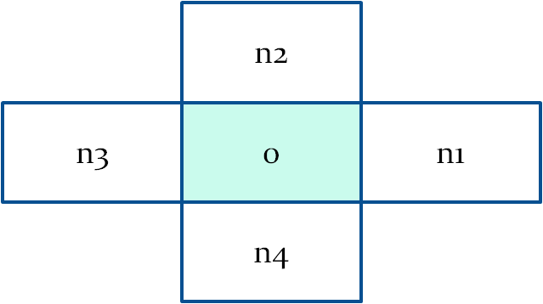

Figure : Stencil for de-structured mesh

The starting equation for this analysis is the same 2D hyperbolic equation of 4.1 and its discretized form is

(6.1)

Where

(6.2)

Here h = volume of the cell, Sk and Vk are area and velocity vector of kth face the cell respectively. The quantities uk and u0 are values at cell centres.

The artificial diffusion term is again broken into 2nd and 4th order terms.

(6.3)

(6.4)

(6.5)

The quantities represent 2nd derivatives of u at cell centres. They are usually replaced by undivided deference of u. and are parameters as defined in [1]. Note that is not an independent parameter. It’s value depends upon .

Using the model solution ,

(6.6)

This expression is same as what we got for structured discretization in eq. (4.5). For the artificial dissipation, the 2nd order term also turns out to be same as that of structured variant. Only the 4th order dissipation term differs (due to a different stencil).

(6.7)

(6.8)

()

This is an important result that in case of regular quadrilateral (or hexahedral for 3D), the unstructured algorithm of [2] mimics the structured algorithm with differences limited to only 4th order terms. This has also been the author’s experience while validating TACOMATM [5] for unstructured grid capability.

|  |  |
| --- | --- |
| Structured | De-structured |

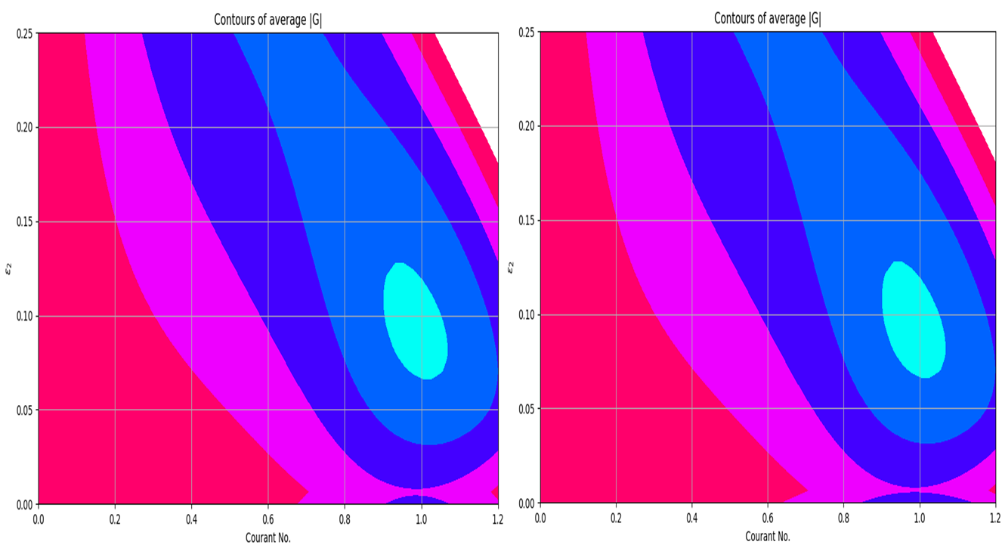

Figure : Comparison of average dissipation for structured and de-structured methods

The above picture clearly shows that the difference in diffusion behaviour is limited to narrow band of < 0.004 (k4=1/256) where 4th order dissipation is active.

|  |  |
| --- | --- |
| Structured | De-structured |
| 2d_struct_jst_avg_Gmod_4th_order.png | 2d_destruct_jst_avg_Gmod_4th_order.png |



Figure : Average diffusion comparison for epsilon < 0.004

# Triangular meshes

Next, the unstructured version of JST algorithm is analyzed on triangular meshes. To keep the mathematical complexity in check, it was assumed that the domain is discretized with equilateral triangles of uniform size.

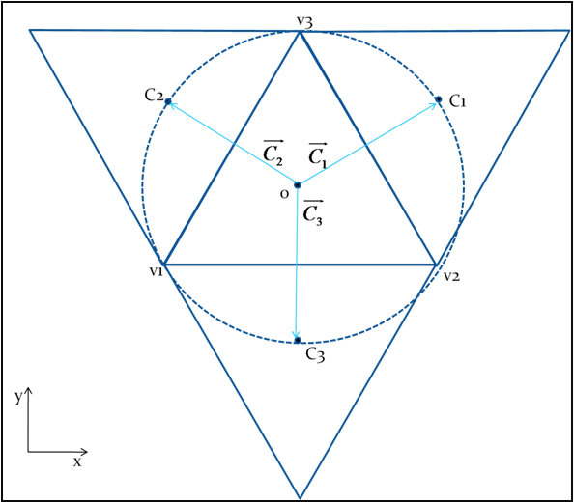

Figure : Equilateral triangle with it's neighbours

Certain properties and assumptions about equilateral triangle based tessellation are listed. These properties and assumptions are used in deriving the final dispersion and dissipation relations.

1. All triangles are of equal size with edge length of
2. The origin is assumed to lie at the centroid of the base triangle about which equations are being derived.
3. For equilateral triangles, centroid, in-centre and circum-centre are coincident. Henceforth, this point is referred to as “centre” of the triangle.
4. Centre of neighbouring triangles lie on circum circle of base triangle.
5. Vectors are perpendicular to respective edges of the triangle v1v1v3.
6. Circum radius and

The equations from 6.1 to 6.5 hold for triangular tessellation case as well. Representing the solution in discrete Fourier form one can represent the neighbour cell centre values as

(7.1)

Here, is the wave number vector as described earlier. This should not be confused with the subscript k, which is index of the neighbour or side. The subscript 0 represent the value at the base triangle. is the vector joining centre of base triangle with the centre of kth neighbour.

(7.2)

(7.3)

Because of directional symmetry, the wave angle vector is described differently from rectangular grid case.

(7.4)

R here is the circum radius.

With these terms, the discretized form of Q(u) and D2(u) and D4(u) can be found after some algebraic manipulation. The symbolic package SymPy in Python was used for some specific manipulations and cross verification of terms.

(7.5)

Replacing these expressions in eq. 6.1, an equation in form of 4.8 can be created. Then, using the amplification factor formula for RK3 step as in equation 4.9 amplification factor for triangular mesh can be obtained. For this, terms within brackets in 7.5 are assigned different variable names.

(7.6)

The 4th order dissipation terms were evaluated but their inclusion did not impact the behaviour of scheme and hence have been omitted here for clarity.

Here, and are complex numbers. This would give

(7.7)

(7.8)

Amplification factor can then be calculated using eq. 4.9.

# Results

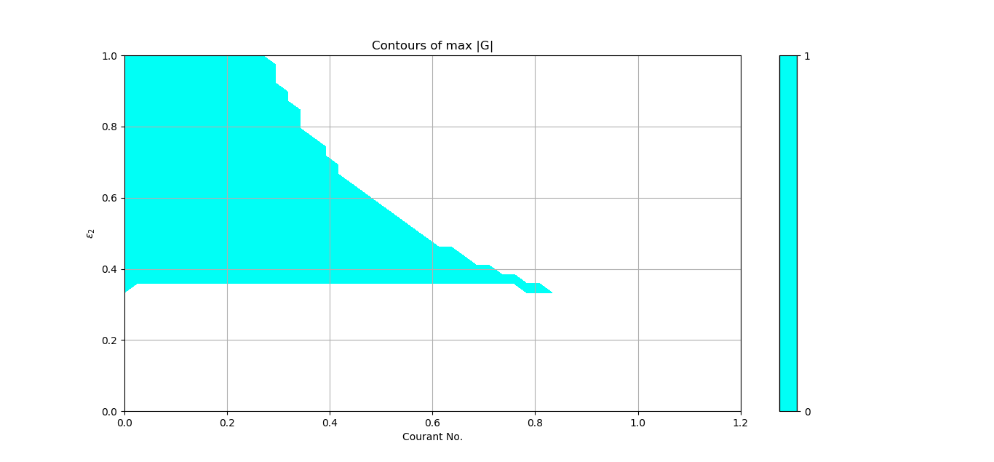

Figure : Stability region for unstructured JST scheme on triangular meshes

This plot shows that the range of complete stability for uniform triangular mesh is much restricted as compared to structured analysis. Reasons for this are not fully understood yet. It could possibly be the reason that scaling coefficients for unstructured meshes need some amount of “tuning” to make the solver stable for wide range of application. But, author has not experienced that much of stability problem with unstructured implementation as the plot above might suggest.

The plots below show the contours of average diffusion and maximum phase errors in plane of .

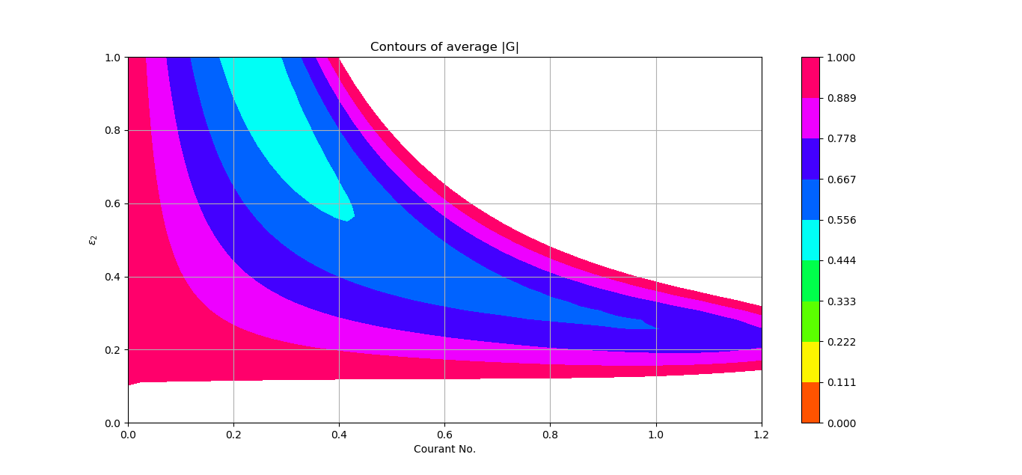

Figure : Average diffusion

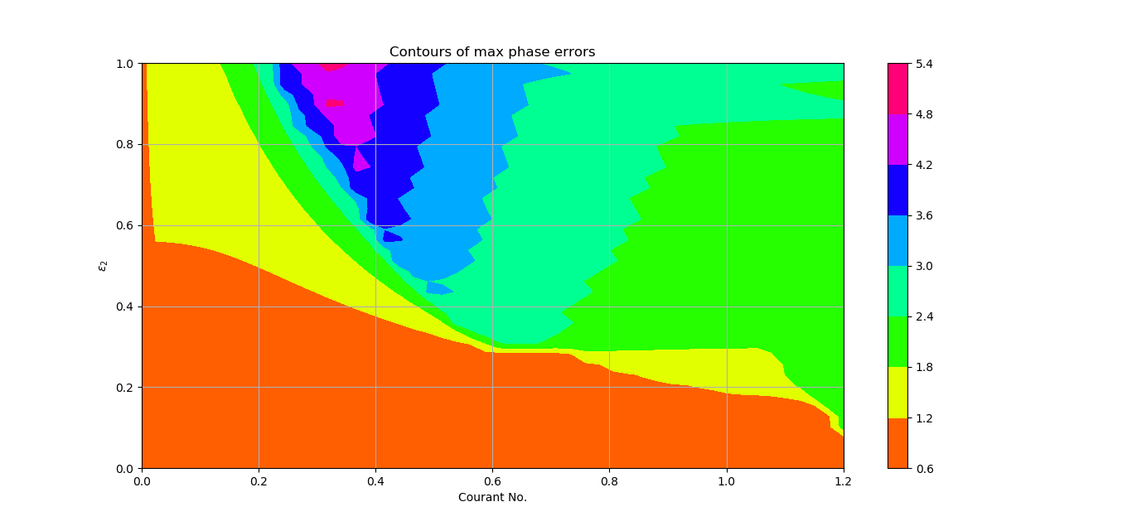

Figure : Max phase error

Finally, a code was written to that propagates an initial disturbance using the JST scheme on rectangular and triangular meshes and the relative positioning of disturbance is studies after one time period. All boundaries are periodic.

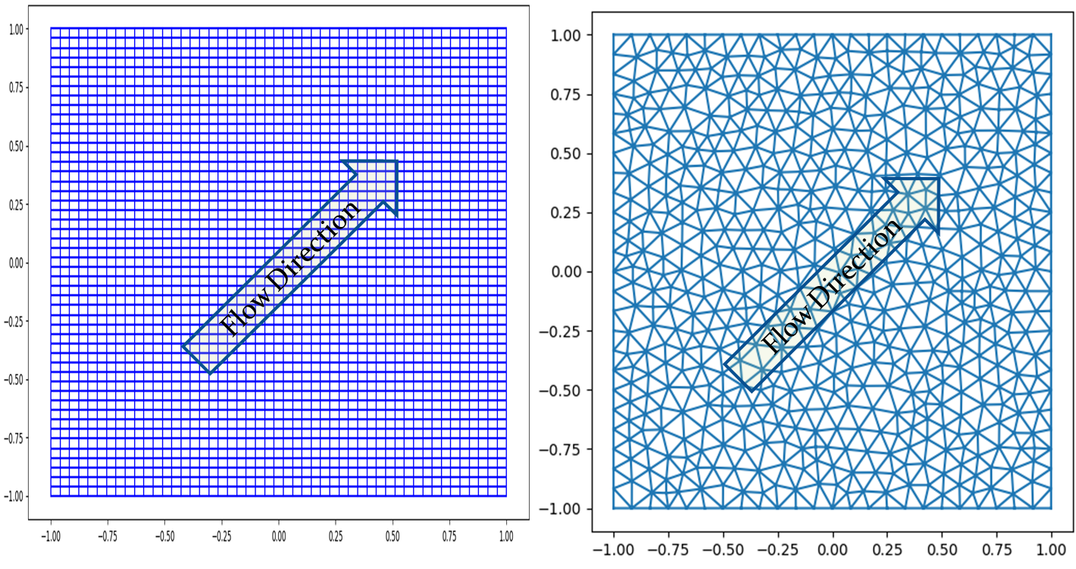

Figure : Rectangular and triangular grid for wave propagation

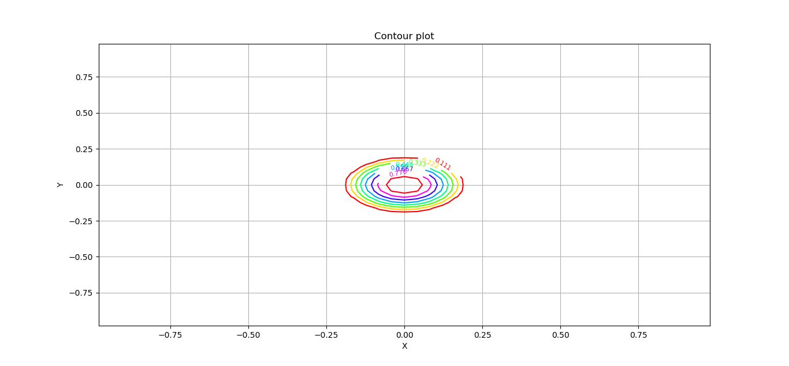

Figure : Initial disturbance

The above initial disturbance is created by following initialization and then propagated at 45 degrees to positive x-axis.

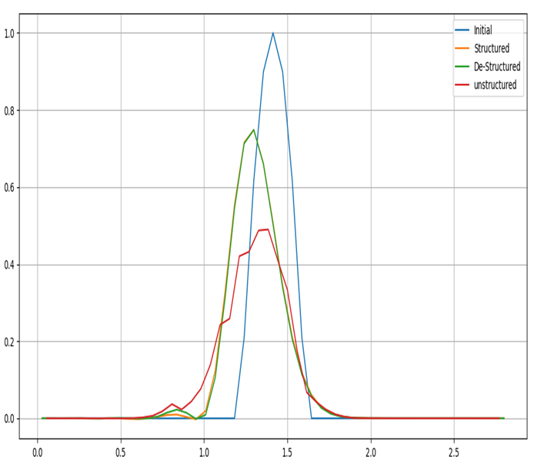

Figure : U along line y=x, initial and then after 1 period.

The above plot is the value of “u” after one period, compared against initial magnitude for structured, de-structured and unstructured. Structured and de-structured is indistinguishable except for the secondary numerical peak at around x=0.75. This could be due to the difference in group velocity caused by difference in 4th order dissipation. The unstructured algorithm on triangular mesh shows lot more dissipation as expected.

# Future work

The stability region for unstructured algorithm on triangular meshes (figure 8) needs further understanding and validation. It is a well known fact that the unstructured algorithm on triangular meshes is more dissipative, but that should render it more stable. This warrants further study.

# Bibliography

1. Jameson, A., Schmidt, W. and Turkel, E., 1981, June. Numerical solution of the Euler equations by finite volume methods using Runge Kutta time stepping schemes. In *14th fluid and plasma dynamics conference* (p. 1259).
2. Jameson, A. and Mavriplis, D., 1986. Finite volume solution of the two-dimensional Euler equations on a regular triangular mesh. *AIAA journal*, *24*(4), pp.611-618.
3. FOI. Edge - Theoretical Formulation. Technical Report FOI dnr 03-2870, Swedish Defence Research Agency (2007) ISSN-1650-1942
4. Hirsch, C., 2007. *Numerical computation of internal and external flows: The fundamentals of computational fluid dynamics*. Elsevier.
5. https://scientific-sims.com/cfdlab/WORKSHOP/assets/TALKS/mitchell.talk.pdf